Instruksi Kerja: Pengecekan Sling Belt |  | Doc. No.: WI-EHS-20
 |  | REV. 0 | Hal: 1/1
No | Deskripsi | Keterangan | Area Kerja
 | 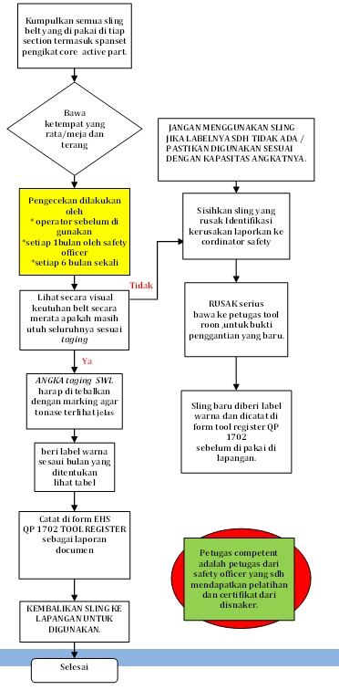 | VISUAL CHECK  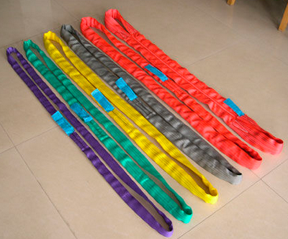  TAGGING SLING  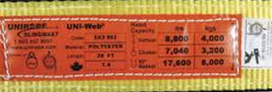  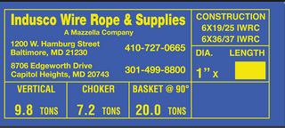  SEBAB SLING RUSAK  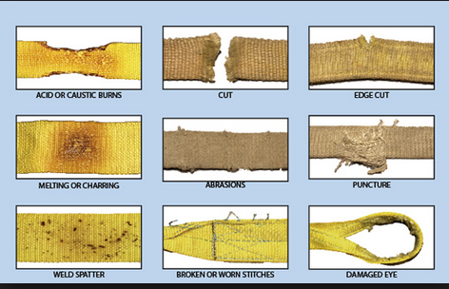  WARNA SLING  